**PHYSICAL FEATURES OF THE VVER-1200 REACTOR CORE REFLECTOR MODEL IN SERPENT CODE**

Usheva K.I.1, Kuten S.A.1, Khruschinsky A.A.1, Babichev L.F.2

*1 Institute for Nuclear Problems,* *Belarusian State University, Minsk, Belarus;*

*2 Joint Institute for Power and Nuclear Research - Sosny, NASB, Minsk, Belarus*

E-mail: k.usheva93@mail.ru

Reactor codes (BIPR, DYN3D [1], etc.) based on solving the neutron transport equation in the diffusion approximation are widely used to analyze stationary and transient processes in the reactor core. To perform such type of calculation it is necessary to create a XS library - a set of macroscopic cross sections and constants. It is usually calculated using spectral codes such as deterministic (HELIOS, TVS-M, etc.) or Monte Carlo (Tripoli, Serpent [2], etc.).

When modeling the whole reactor core, the question is about the boundary conditions at the outer boundary of the fuel part. In VVER-type reactor, the environment of the fuel part (baffle and other internal elements) plays the role of a reflector for thermal neutrons, in which there is no neutron source.

To calculate and create a XS library of sections for the reflector, a model of ¼ reactor core was created (Fig. 1), which allows correctly take into account the full spectrum of neutrons created in the fuel part of the core and interacting with a two-layered reflector (R1-R2).

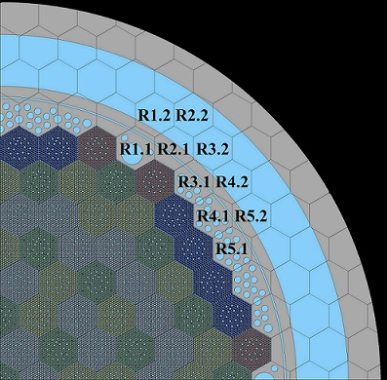

*Fig. 1. Model of radial reflector.*

In this paper, a model of a radial reflector for VVER-1200 reactor is proposed for calculating and preparing a XS library using Serpent Monte Carlo code for DYN3D diffusion code, taking into account physical features at the reactor core outer boundary.

1. U. Rohde, S. Kliem, U. Grundmann, S. Baier, Y. Bilodid et. all. The reactor dynamics code DYN3D – models, validation and applications, Progress in Nuclear Energy 89, p. 170-190 (2016).

2. J. Leppänen. Serpent – a Continuous-energy Monte Carlo Reactor Physics Burnup Calculation Code. User’s Manual. VTT Technical Research Centre of Finland, 164 p. (2015).